Appendix

to Technical task, Lot no._______
Novosibirsk _________ 2019

Technical Requirements to the Quality of
AZS Fused Cast Refractory Materials

- General
Classification: alumina-zirconium-silica product, type AZS30 / 40 ISO 10081-4.
Main components of the raw material: alumina, zirconium dioxide, zirconium silicate, sodium carbonate.
Type of refractory: fused cast.
Main application: container glass, flat glass, special glass.

- Classification of AZS Fused Cast Refractory Materials
AZS fused cast refractories are made with long-arc melting and oxidizing. They can be classified by ZrO₂ content and casting methods as shown below:

a) AZS 33:
РТ—regular casting (AZS33PT);
ZWS—reinforced casting (AZS33ZWS);
WS—void-free casting (AZS33WS).

b) AZS36:
РТ—regular casting (AZS36PT);
ZWS—reinforced casting (AZS36ZWS);
WS—void-free casting (AZS36WS).

c) AZS41:
РТ—regular casting (AZS41PT);
ZWS—reinforced casting (AZS41ZWS);
WS—void-free casting (AZS41WS).

- Chemical and Physical Properties of AZS Fused Cast Refractories
  - Chemical Composition (determined on a calcined substance (1025 °C) according to EN ISO 12677)
Table 1. Target Values of the AZS Chemical Composition
Chemical composition, % |  | AZS 33 | AZS 36 | AZS 41
Al₂O₃ |  | Residual | Residual | Residual
ZrO₂+HfO₂ | ≥ | 32.5 | 35 | 40
SiO₂ | ≤ | 15.5 | 14 | 12.5
Na₂O + K₂O | ≤ | 1.6 | 1.5 | 1.3
Fe₂O₃+ TiO₂+CaO+MgO+B₂O₃ | ≤ | 0.3 | 0.3 | 0.3

  - Bulk density of products
Table 2. Target Values of Bulk Density for AZS Products
Item |  | AZS-33PT | AZS- 33ZWS | AZS- 33WS | AZS-36ZWS | AZS-36WS | AZS-41 ZWS | AZS-41 WS
Bulk density*, g/cm³. Determined by EN 993-1 | ≥ | 3.42 | 3.65 | 3.72 | 3.80 | 3.85 | 3.95 | 4.00
* The bulk density standard applies to products of more than 50 kg.

  - Physical Properties and Performance Indicators
Table 3. Target Values of Physical and Mechanical Properties and Performance Indicators of AZS Products
Item |  | Unit | AZS 33 | AZS 36 | AZS 41
Corrosion resistance to molten glass in static state (soda-lime glass at 1500 °С х 36 h). Determined by TC11 | ≤ | mm/24 h | 1.6 | 1.5 | 1.3
Mechanical strength in cold state, determined according to EN 993-5 | ≥ | MPa | 200 | 200 | 200
Refractoriness under load 2·10⁵ Pа. Determined according to ISO 1893 | ≥ | °C | 1700 | 1700 | 1700
Foaming index at contact with glass liquid (soda-lime glass at 1550 °С). Determined by TC11 | ≤ | index | 2.0 | 1.5 | 2
Vitreous phase exudation  (1500 °C x 4 h) | ≤ | % | 3 | 2 | 2
Linear expansion (1000 °С) |  | % | by test | by test | by test

  - Crystallographic Structure Analysis
Results of crystallographic structure analysis depend on the casting method and sampling points. The table shows typical values for AZS products.
Table 4. Typical Phase Composition of AZS Products
Phase | AZS 33 | AZS 36 | AZS 41
Alumina (corundum) | 46.5% | 43.5% | 42%
Zirconia | 32% | 35.5% | 40%
Vitreous phase | ≤21% | ≤20% | ≤17%

- Quality Control of AZS Fused Cast Refractory Products Acceptance of Quantity and Quality of the Goods
Quality control of AZS fused cast refractory products includes control of raw materials, results of intermediate production stages, and finished products. The control should be performed by the Customer’s representatives during audits, pre-assembly, and based on the test results for samples. The test results for samples should be compared with target values according to sections 3 and 4.3 of the Technical Requirements.
To perform an audit (to check the Goods quality and quantity), the Customer’s representative should visit the manufacturing plant.

Audit No. 1
The audit should be performed before the material is poured into molds for the Goods manufacturing and during the material pouring. The Vendor should notify the Customer about the date when everything is ready for audit No. 1 not later than 15 calendar days before the date.
The audit includes:
  - Check if quality certificates for the raw materials, which are intended for manufacture of batches of Customer’s products, comply with technical requirements of the Vendor of AZS fused cast refractory products. All raw materials, which are used to manufacture AZS fused cast refractory products, should undergo on-receipt inspection to ensure they comply with technical requirements of the Vendor of AZS fused cast refractory products. The Customer should be provided with original documents containing laboratory results, which should confirm the quality check of the raw materials, as well as with a possibility to take photos and photocopies of the documents.
  - Random check of molds and their arrangement in heat-insulated containers. During molds assembly, the molds for melter sidewall blocks and throat blocks should be randomly checked for compliance with geometric dimensions. All blocks of the furnace should be manufactured using the same technology of block casting molds manufacturing. When assembled molds are being placed into heat-insulated containers, their arrangement and the quality of thermal insulation filling should be randomly checked.
  - Visual inspection of the raw materials used for the Goods manufacturing, check of the batch/cullet ratio, check of the quality of cullet, and specification of the batch and cullet mass for the composition. The Customer may take raw samples for a further check. The samples should be taken in attendance of both parties; an act should be compiled, and bags with the selected samples should be sealed.
  - Check analysis results for the samples, which were taken during pouring. To check the stability of chemical composition of the products during casting, melt samples of each brand of AZS products should be taken from different batches at least 3 times to determine their chemical composition and provide the analysis results.
Audit No. 2
The audit should be performed when the staff starts opening the boxes with blocks for melter, refractory sill, bottom, and throat. The Vendor should notify the Customer about the date when everything is ready for audit No. 2 not later than 10 days before the date.
The audit includes:
  - Random check of surface condition and the quality of blocks after the molds have been cleaned from material. Before machining, the surface condition and quality should be randomly checked for melter sidewalls and bottom, throat, and walls of furnace superstructure.
  - Random check of the blocks topping surface during machining. Photos of the check results should be taken.
  - Check of traceability of the blocks cast for the Customer at the pouring/annealing/finishing stages.
  - Samples selection: 100х100х100 mm (9 pcs.) and 10х10х130 mm (9 pcs.) (Table 5). Every sample should be marked with permanent paint for identification purposes. The parties should confirm the samples selection, their number, and method of selection in Audit 2 Report. To check chemical composition, bulk density, mechanical strength in cold state, refractoriness under load, foaming index and vitreous phase exudation, and the coefficient of high-temperature thermal expansion of the finished products, 100x100x100 mm samples should be prepared from random blocks. To conduct tests for corrosion resistance to molten glass, the size of the prepared samples should be 10x10x130 mm. Melter sidewall block samples should be cut out from one area of the working surface: at the bottom of the mould. One set of samples is required for testing at an independent laboratory (the selected independent laboratory should be approved by both parties); the other two sets of samples should be sent to the Customer together with the blocks specified in the Order. The samples should be taken in attendance of both parties; an act should be compiled, and bags with the selected samples should be sealed. The samples should be sent to the independent laboratory by express mail from the Vendor’s location. The samples should be handed over to courier in attendance of the Customer’s representative. The Vendor should provide the Customer with information to track the samples delivery on the site of the courier company.
Table 5. List of Samples of AZS Products
No. | AZS brand | Sampling point | Sample dimensions, mm | Number of samples, pcs.
1 | AZS-33 | Bottom paving 600х400х100 mm from AZS0317WSP | 100х100х100 | 3
 |  |  | 10х10х130 | 3
2 | AZS-36 | Bottom part of block 400х250x1500 mm from AZS0327ZWS | 100х100х100 | 3
 |  |  | 100х100х100 | 3
3 | AZS-41 | Bottom part of block 400x250x1150 mm from AZS0337WS | 10х10х130 | 3
 |  |  | 10х10х130 | 3

The Customer’s representative should select the following samples: 600x400x100 mm paving from AZS33WSP, 400x250x1500 block from AZS36ZWS, and 400x250x1150mm block from AZS41WS. The blocks for the samples should be selected after annealing and before machining. The vendor must produce additional blocks to ensure the sampling procedure described above.
Audit No. 3
The audit should be carried out after the Vendor pre-assembles the furnace parts from blocks on a bench. The Vendor should notify the Customer about the date when everything is ready for audit No. 3 not later than 10 days before the date.
The audit includes:
  - Complete inspection of weight and casting surface of all blocks of melter sidewalls, doghouse arch, throat, refractory sill, and thermocouple blocks. Photos of the check results should be taken. The bulk density of the product material should not be less than the target values (Table 3.2 of the Appendix).
  - Blocks random check with “Ground Penetrating Control” to check eventual porosity in glass contact blocks.
  - Check of the pre-assembly. The quality standards specified in section 5 of the Technical Requirements for visual inspection and check of the pre-assembly should be applied.
  - Check if the packaging complies with the corresponding requirements.
  - Check that the test results of the samples taken during audit No. 2 correspond to the target values for the chemical and physical properties of AZS fused cast products according to section 3 of the Appendix.

Audit No. 4

The audit is carried out during furnace heat up at a specified temperature. The audit includes:
4.13. The Vendor shall provide the Customer with recommendations on heating up of the furnace built from the Vendor’s AZS products.
4.14. The Vendor shall send a representative at its own expense to verify that the recommendations on products heat up have been followed during heating up from 1000 °C to 1250 °C and to advise Customer’s specialists on correct heating up of the Vendor’s AZS products.

A separate report with audit results should be prepared for every audit. Representatives of the Vendor and the Customer should sign the report.

- Quality Standard for Visual Inspection of AZS Fused Cast Refractories
5.1. Dimensions
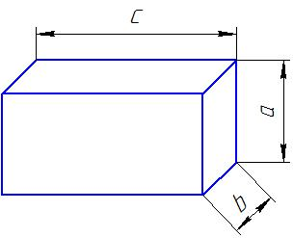
а) A steel tape (mm) should be used to measure the dimensions.
b) The tolerances for machined surfaces are +1÷-2 mm, the tolerances for rough surfaces are +2÷-3 mm.
c) The thickness tolerance of paver blocks is +1÷-2 mm.
d) The thickness tolerance of sidewall blocks is +2÷-2 mm.
5.2. Squareness

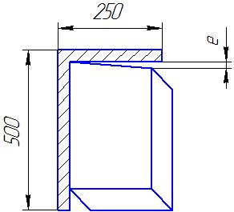

The squareness of surfaces should be measured with metal squares.
Firmly hold one side of a square (side length: 500×250 mm) against the product surface and measure the distance between the other side of the square and the other surface of the product:
а) machined surfaces: e ≤ 1 mm.
b) rough surfaces: e ≤ 2 mm.

  - Flatness:
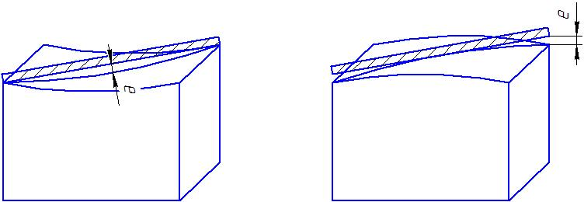

- Working surfaces: set a metal bar (500 mm) cornerwise on a working surface of the product:
а) Depth for machined surfaces: e ≤ 1 mm.
b) Depth for rough surfaces: e ≤ 2 mm.
c) Depth for rough surfaces (РТ casting): e ≤ 5 mm.
- Non-working surfaces:
а) Depth for machined surfaces: e ≤ 1 mm.
b) Depth for rough surfaces: e ≤ 2 mm.
- Casting surface (PT casting):
а) No convexity is allowed.
b) Concavity: е ≤ 10 mm.
5.4 Casting Void. Casting voids should be measured with a metal tape at the right angle to the surface they are located on.
а) For PT and QX blocks, voids are controlled by weight and shapes; size and depth of a void ≤ 120 mm;
b) ZWS: depth (ZWS) ≤ 80 mm;
c) WS: depth (WS) ≤ 15 mm.
Upon agreement with the Customer, voids can be filled with mortar after acceptance of the products.

  - Corner and Edge Spalls
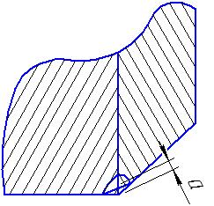
- Corner spalls: the size of a corner spall is determined by distance “a” (the distance from the centre of the damaged surface to the vertex of the corner).
а) Working surfaces: corner spall “a” ≤ 25 mm; a block may have only one damaged corner.
b) Non-working surfaces: corner spall “a” ≤ 40 mm; a block may have only one damaged corner.
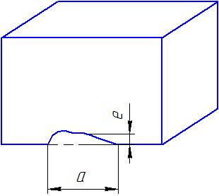

- Edge spalls should be measured with a metal ruler (mm). The maximum “e” value for two mating surfaces should be taken.
а) Working surfaces: edge spall “e” ≤ 15 mm; spall length “a” ≤ 1/4 of the edge length; a block may have only one damaged edge.
b) Non-working surfaces: edge spall “e” ≤ 25 mm; spall length “a” ≤ 1/4 of the edge length; a block may have up to 2 damaged edges.
5.6. Cracks
а) Crack length ”а” should be measured with a metal ruler (mm). Crack width “b” should be measured with a metal feeler.
b) The actual length “a” should be measured for cracks, which are parallel to the plane; the projected (on the plane) length should be measured for cracks, which are not parallel to the plane.

- Sidewall blocks:
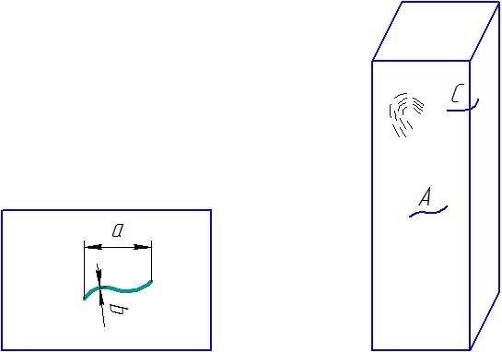

а) Through cracks are not allowed.
b) Surface skin cracks (width “b” ≤ 0.5 mm) are allowed in the form of a grid covering not more than 25% of the working surface.
c) Up to 3 “A” cracks are allowed (width “b” ≤ 1 mm; length “a” ≤ 1/4 of the width of the block surface they are located on).
d) The working surface should have no “A” cracks (width “b” ≥ 1 mm); all other surfaces may have up to 1 “A” crack if “a” ≤ 20 mm).
e) A block may have one “C” cross crack (width “b” ≤ 1 mm; length does not exceed 1/4 of the width of adjoining surfaces).
f) No “C” cross cracks (passing through two or more edges) are allowed.

- Paver blocks and special bottom blocks:
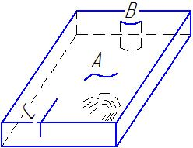

а) Through skin cracks and “B” through cracks are not allowed.
b) Surface skin cracks (width “b” ≤ 0.5 mm) are allowed in the form of a grid covering not more than 25% of the working surface.
c) Up to 6 “A” cracks are allowed (width “b” ≤ 1 mm; length “a” ≤ 1/4 of the width of the block surface they are located on).
d) The working surface should have no “A” cracks (width “b” ≥ 1 mm); all other surfaces may have up to 3 “A” cracks if “a” ≤ 20 mm).
e) A block may have 2 “C” cross cracks (width “b” ≤ 1 mm; length “a” ≤ 1/4 of the width of adjoining surfaces).
e) A block may have only one “C” cross crack passing through another edge (width “b” ≤ 1 mm; length “a” ≤ 1/4 of the width of the smallest surface).

- Tuckstones:
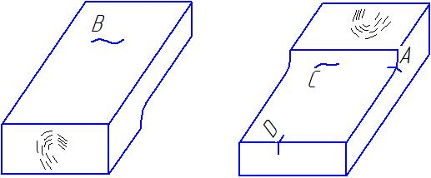
а) Through skin cracks and through cracks are not allowed.
b) Surface skin cracks (width “b” ≤ 0.5 mm) are allowed in the form of a grid covering not more than 25% of the surface they are located on.
c) Corner cracks, skin cracks “A” and “C” are not allowed.
d) Cracks “B” and “E” (width “b” ≤ 1 mm; length “a” ≤ 1/4 of the width of the block surface they are located on) are allowed.
e) “D” cross cracks (width “b” ≤ 1 mm; length “a” ≤ 1/4 of the tuckstone thickness) are allowed.
f) A block may have up to 2 skin cracks or cracks of each type (except cracks “А” and “С”).

- Arch blocks:
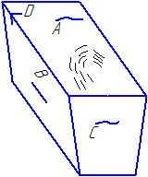

а) Through skin cracks and through cracks are not allowed.
b) Surface skin cracks (width “b” ≤ 0.5 mm) are allowed in the form of a grid covering not more than 25% of the surface they are located on.
d) Cracks “A”, “B”, and “C” (width “b” ≤ 1 mm; length “a” ≤ 1/4 of the width of the block surface they are located on) are allowed.
e) “D” cross cracks (width “b” ≤ 1 mm; length “a” ≤ 1/4 of the width of adjoining surfaces) are allowed.
f) A block may have up to 2 skin cracks or cracks of each type.

- Channel blocks:
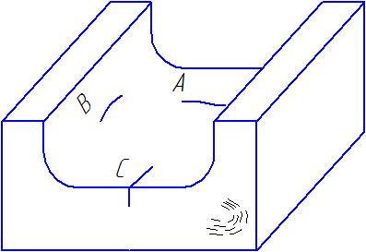

а) Through cracks are not allowed.
b) Surface skin cracks (width “b” ≤ 0.5 mm) are allowed in the form of a grid covering not more than 25% of the surface they are located on.
c) “A” cracks (width “b” ≤ 1 mm; length “a” ≤ 1/2 of the width of the block surface) are allowed.
d) “B” cracks (width “b” ≤ 1 mm; length “a” ≤ 1/3 of the width of the block surface) are allowed.
e) “C” cross cracks (width “b” ≤ 1 mm; length “a” ≤ 1/2 of the width of the smallest surface) are allowed.
f) A block may have up to 3 skin cracks or cracks of each type.

- Peep hole blocks and burner blocks:
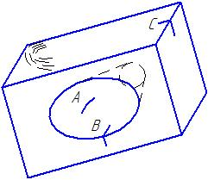
а) Through skin cracks and through cracks are not allowed.
b) Surface skin cracks (width “b” ≤ 0.5 mm) in the form of a grid are not allowed.
c) A block may have up to 1 “A” crack (width “b” ≤ 1 mm; length “a” ≤ 1/2 of the width of the block surface).
e) A block may have one “C” cross crack (width “b” ≤ 1 mm; length “a” ≤ 1/4 of the width of adjoining surfaces).
f) A block may have up to 2 skin cracks or cracks of each type (except cracks “А” and “С”).

- Cracks on the casting surface (PT and QX casting):
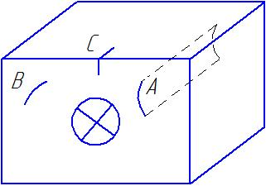

а) “A” through cracks are not allowed.
b) Surface skin cracks (width “b” ≤ 0.5 mm) are allowed in the form of a grid covering not more than 50% of the casting surface.
c) A block may have up to 3 “B” cracks (width “b” ≤ 1 mm; length “a” ≤ 1/2 of the width of the block surface).
  - Surface Inclusions
All block surfaces except for the casting surface should have no surface inclusions of molds and other materials. The casting surface may have inclusions of molds and other materials, but the area of the inclusions should not exceed 1% of the casting surface.
Surface Porosity
а) Porosity of the working surface should not exceed 25 pores per 1 dm² (pore diameter “d” ≤ 5 mm) at the area of maximum pores concentration.
а) Porosity of the seam surfaces should not exceed 15 pores per 1 dm² (pore diameter “d” ≤ 3 mm) at the area of maximum pores concentration.
а) Porosity of the casting surface should not exceed 15 pores per 1 dm² (pore diameter “d” ≤ 10 mm) at the area of maximum pores concentration.

- Quality Standard for Pre-Assembly of AZS Fused Cast Refractories

The Vendor should perform pre-assembly of all furnace components: melter bottom, sidewalls, breast walls, tuckstones, and ports (including port neck sidewalls). The pre-assembly should meet the Technical Requirements.

6.1. Stages of Inspection
a) The blocks used in the pre-assembly should undergo visual inspection according to section 5 “Quality Standard for Visual Inspection of AZS Fused Cast Refractories”.
b) The gaps between the blocks of the pre-assembly should be measured with a metal feeler gauge. Depth of the gaps measurement should be more than 20 mm.
c) Flatness depends on types of the blocks and their characteristics and should be controlled with a laser level gauge. Flatness tolerance for the pre-assembly blocks should not exceed 5 mm.
d) Dimensions.
Block dimensions should be checked against the drawings and measured with a metal ruler and a metal tape with a scale in millimetres. From the viewpoint of dimensions, general dimensions of the pre-assembly take precedence over the dimensions of single blocks.
e) Final inspection of the pre-assembly should be performed according to the furnace assembly drawings and the Customer requests.
6.2. Special Requirements to Pre-Assembly
- Melter bottom (including melting end, neck, and cooling end):
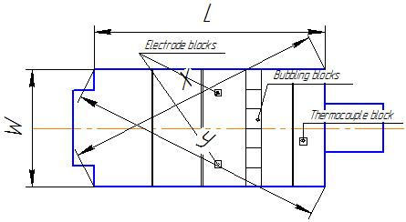
а) Standard size of paver blocks: 600×400×(75/100/120/150) mm.
b) Overall dimensions should correspond to the values specified in the table:
Item | Tolerance
Joint | 90% ≤ 1.0 mm; 1.0 mm ≤ 10% ≤ 1.5 mm
Length and width (L and W) | ≤ 5 m | 0÷-5 mm
 | 5 m÷10 m | 0÷-0.1%
 | ≥ 10 m | 0÷-5 mm
Diagonal (X and Y) | (X-Y) ≤ 10 mm

c) Expansion joints should be reserved according to the drawings on the pre-assembly stage. If expansion joints are reserved for all products, they can all be taken into account in the pre-assembly. The tolerance for expansion joints is -1÷+3 mm.
d) Fixed points.
The following elements are considered as fixed points: bubbler blocks, electrode blocks, submerged walls, thermometer hole blocks. The tolerances for these elements from the axis of the furnace should be 0÷-5 mm.
e) Flatness: the step between two adjacent blocks should not exceed 2 mm.

- Sidewall blocks:
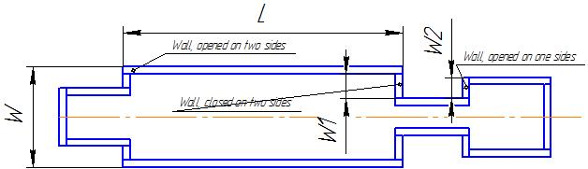

a) Overall dimensions should correspond to the values specified in the table:
Item |  | Wall closed at both ends | Wall opened at one end | Wall opened at both ends
Joint | Height ≤ 1600 mm | 90% ≤ 0.8 mm; 0.8 mm ≤ 10% ≤ 1.0 mm
 | Height ≥ 1600 mm | 90% ≤ 1 mm; 1 mm ≤ 10% ≤ 1.5 mm
Length and width  （L and W） | ≤ 5 m | 0÷-5 mm | 0÷-10 mm | +5÷-10 mm
 | 5 m÷10 m | 0÷-0.1%
 | ≥ 10 m | 0÷-10 mm

b) Expansion joints should be reserved according to the drawings on the assembly stage. If expansion joints are reserved for all products, they can all be taken into account in the pre-assembly. The tolerance for expansion joints is -1÷+3 mm.
c) Flatness: the step between two adjacent blocks should not exceed 2 mm for non-working surface and should not exceed 3 mm for working surface; the height should not exceed 3 mm.

- Breast walls and tuckstones:
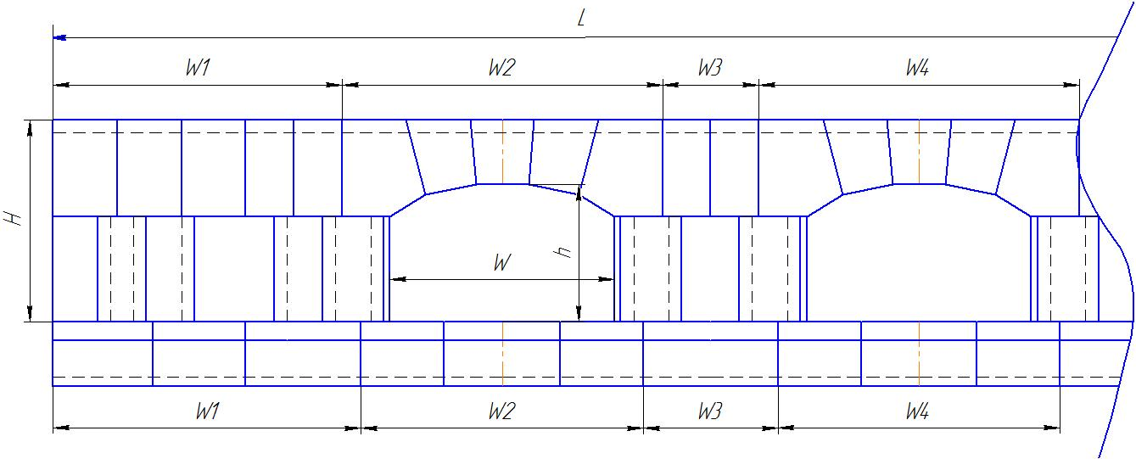
a) Overall dimensions should correspond to the values specified in the table:
Item | Tolerance
Joint | 90% ≤ 1 mm; 1 mm ≤ 10% ≤ 1.2 mm
Wall width (L) | 0÷-10 mm
Height (H) | +2÷-2 mm
Port width (W) | +3÷-5 mm
Height (h) | +5÷-5 mm
Unit Width (w1/w2/w3…) | +3÷-3 mm
Tuckstone unit width (w1/w2/w3…) | +1÷-3 mm

b) Expansion joints should be reserved according to the drawings on the assembly stage. The tolerance for expansion joints is -1÷+2 mm.
c) Flatness: the step between two adjacent blocks should not exceed 5 mm for rough working surface and should not exceed 2 mm for machined non-working surface.
d) The tolerances for peep hole blocks and thermocouple hole blocks should be ≤ 10 mm.
e) The joints of arch blocks should be ≤ 0.8 mm.

- Port blocks (including regenerator entrance blocks):
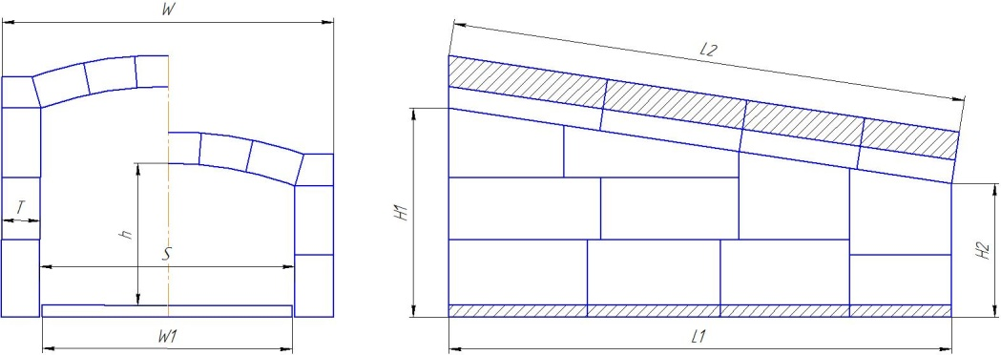

a) Overall dimensions should correspond to the values specified in the table:
Position | Item | Tolerance
Furnace wall | Wall width (S) | +3÷-3 mm
 | Wall height (h) | +5÷-5 mm
Assembled arch | Length (L2) | 0÷-3 mm
 | Width (W) | +3÷-3 mm
Sidewall | Length (L1) | +2÷-2 mm
 | Height (H1, H2) | +2÷-2 mm
 | Thickness (T) | +1÷-2 mm
Paving | Length (L1) | 0÷-3 mm
 | Width (W1) | 0÷-3 mm
 | Thickness (T) | +2÷-2 mm

b) Arch block joints should be ≤ 0.8 mm. Joints of sidewalls and paver blocks should be ≤ 1.2 mm.
c) Flatness: the step between two adjacent blocks should not exceed 3 mm for rough working surface (hot surface) and should not exceed 2 mm for machined non-working surface (cold surface).
d) Flatness of contact surfaces of arch blocks, melter walls, and breast wall blocks should be ≤ 2 mm.
e) The tolerance for thermocouple hole blocks should be 0÷-2 mm.
6.3 Pre-Assembly Marking
а) Every block of the pre-assembly should have marking. The marking should include the pre-assembly number, the block number, brand of the refractory, and other identification data of the Vendor.
b) The marking should be made on the working surface (on the inner side of the furnace), except for special cases.
c) The marking should be clear, well-arranged, full, and recognizable.
d) The Customer should be provided with the pre-assembly drawing (including the pre-assembly No. and the drawing No.) for pre-assembly acceptance at the Vendor’s warehouse.

- Requirements for Packaging, Transportation, and Storage of AZS Fused Cast Refractories

7.1 Packaging
а) Products should be wrapped in a waterproof material and packed in fumigated wooden boxes made of plywood with a minimum thickness of 7 mm; the boxes should be wrapped with lots of plastic tape.
b) The gross weight of each pallet should not exceed 2 tons.
c) A tight pad should be placed between the blocks to prevent the blocks surfaces from contact.
d) Every box should have a packaging label with the following information located on two adjacent sides:
Consignee:
Name of the Goods (drawing/dimensions, weight, brand):
Pallet No.:
Contract No.:
Gross weight:
Net weight:
Quantity:
Pallet dimensions in mm:
Country of origin of the Goods:
e) Every box and container should have a safety transportation sticker on its visible side.
7.2. Transportation
а) Protect the boxes from collision during loading, transportation, and unloading.
b) The boxes should be loaded and unloaded with a forklift truck. Use special (rigid) hoisting sling when the boxes are loaded and unloaded with a crane.
c) Do not stack the boxes during transportation.
7.3. Storage
а) The boxes should be stored in a dry and well-ventilated room clean from chemicals, at the temperature of +5... +30 ^{о}С.
b) The room floor should be very smooth.
c) The boxes should not be stored in inclined position.
d) The boxes should not be stacked.

Head of the Investment Management Department | Zhuravlev V.
Chief technologist | Nikitin A.

